**Auto Intensity Control of Street Lights**

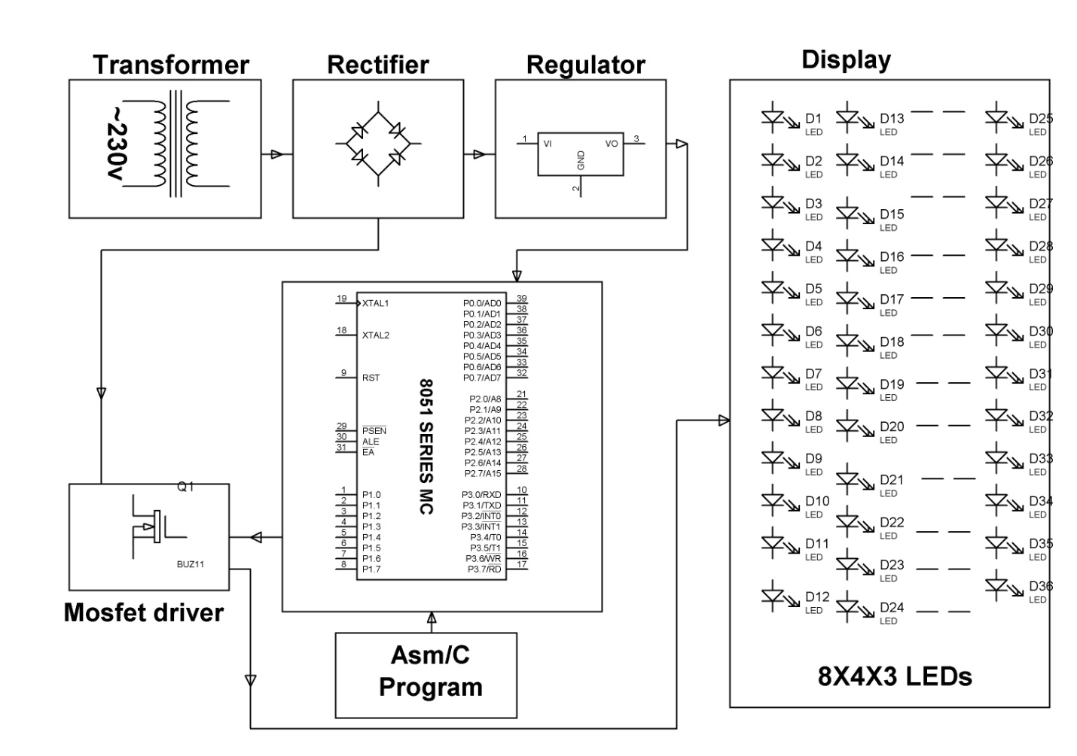

Kit Description: White Light Emitting Diodes (LED) replaces HID lamps in street lighting system to include dimming feature. A microcontroller of 8051 family is used to control the intensity by developing pulse width modulated signals that drives a MOSFET to switch the LEDs according to achieve desired operation.